Start |  |  |  |  |  |  | 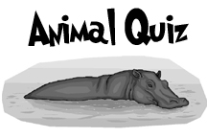
 |  |  |  |  | Go back  2 |  |  |  |  |  |  |  |  |  |  | Roll Back
Trade
places
 |  |  |  |  |  |  |  | Roll the dice. Then answer the trivia question correctly or go back. |  |  |  |  |  |  |  | Go Ahead 2
 |  |  |  |  |  |  |  |  |  |  | Go Back 1
 |  |  | Go Ahead 2 |  |  |  | Trade  Places
 |  |  | Go Ahead 2 |  |  |  |  |  www.bogglesworldesl.com
 |  |  |  |  | Roll Ahead |  |  |  |  |  |  |  |  |  |  | END

