Guess What Question Sheet: Most of these examples come from worksheets found on http://bogglesworldesl.com but teachers can make their own examples as needed.
 | Guess What  Teacher describes something using 'a thing that' and students guess what it is. | 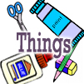 | Things  Students describe something using a relative clause with 'a thing that'.
It's a thing that people use to chop wood, cut wood, dig holes, draw straight lines, gather leaves, take pictures, cut paper, cut food, eat soup. |  | What is a shovel? An axe? A saw? A camera? A pencil? A rake? A broom? A brush? An eraser? A knife? Scissors? A spoon? A ruler? A compass?
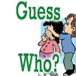 | Guess Who  Teacher describes something using 'a person who' and students guess who it is. | 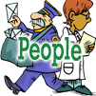 | People  Students describe something using a relative clause with 'a person who'.
It's a person who fixes teeth, helps doctors, flies airplanes, plays sports, flies spaceships, puts out fires, catches criminals, draws pictures, serves food, cooks food, teaches kids, delivers mail. |  | What is a dentist? A pilot? A farmer? A chef? A waiter? A teacher? A firefighter? A police officer? A doctor? An athlete? An artist? An astronaut?
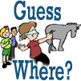 | Guess Where  Teacher describes something using 'a place where' and students guess where it is. | 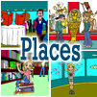 | Places  Students describe something using a relative clause with 'a place where.'
It's place where people borrow book? Order food? See pictures? Save money? Make things? See animals? See fish? Go on the swings? See movies? Learn history? |  | What is a library? A theater? A school? A park? A pool? A museum? A gallery? A store? A factory? A hospital? A bank? An aquarium? A zoo? A restaurant? A playground?
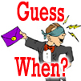 | Guess When  Teacher describes something using 'a time when' and students guess when it is. |  | Times  Students describe something using a relative clause with 'a time when.'
It's a time when flowers bloom, kids make snowmen, farmers harvest crops, people give presents, leaves change color, bears wake up, farmers plant crops, snow covers the ground, kids wear costumes, people give chocolates and say 'I love you,' people play tricks, people go to the beach, people wake up, people go to bed. |  | What is summer? Spring? Winter? Fall? Christmas? Easter? Halloween? April Fool's Day? Valentine's Day? Morning? Night?

